- Copyright for test papers and marking guides remains with West Australian Test Papers.
- The papers may only be reproduced within the purchasing school according to the advertised conditions of sale.
- Test papers must be withdrawn after use and stored securely in the school until October 14

HUMAN BIOLOGY
Unit 3 and 4
2019 Marking Guide

Insert School Logo

Name: _______________________________________________________

Teacher: ___________________________________________________

Time allowed for this paper

Reading time before commencing work: ten minutes
Working time for the paper: three hours

Materials required/recommended for this paper
To be provided by the supervisor
This Question/Answer Booklet
Multiple-choice Answer Sheet

To be provided by the candidate
Standard items: pens (blue/black preferred), pencils (including coloured), sharpener, correction fluid/tape, eraser, ruler, highlighters

Special items: non-programmable calculators approved for use in this examination

Important note to candidates
No other items may be taken into the examination room. It is your responsibility to ensure that you do not have any unauthorised material. If you have any unauthorised material with you, hand it to the supervisor before reading any further.

Structure of this paper

Section | Number of questions available | Number of questions to be answered | Suggested working time (minutes) | Marks available | Percentage of examination
Section One  Multiple-choice | 30 | 30 | 40 | 30 | 30
Section Two  Short answers | 8 | 8 | 90 | 100 | 50
Section Three  Extended answers | 3 | 2 | 50 | 40 | 20
 |  |  |  | Total | 100

Instructions to candidates

1. The rules for the conduct of the Western Australian examinations are detailed in the Year 12 Information Handbook 2019. Sitting this examination implies that you agree to abide by these rules.

2. Write your answers in this Question/Answer booklet preferably using a blue/black pen. Do not use erasable or gel pens.

3. Answer the questions according to the following instructions.

Section One: Answer all questions on the separate Multiple-choice answer sheet provided. For each question, shade the box to indicate your answer. Use only a blue or black pen to shade the boxes. Do not use erasable or gel pens. If you make a mistake, place a cross through that square, then shade your new answer. Do not erase or use correction fluid/tape. Marks will not be deducted for incorrect answers. No marks will be given if more than one answer is completed for any question.

Section Two: Write your answers in this Question/Answer booklet. Wherever possible, confine your answers to the line spaces provided.

Section Three: Consists of three questions. You must answer two questions. Tick the box next to the question you are answering. Write your answers in this Question/Answer booklet.

4. You must be careful to confine your answers to the specific questions asked and to follow any instructions that are specific to a particular question.

5. Supplementary pages for planning/continuing your answers to questions are provided at the end of this Question/Answer booklet. If you use these pages to continue an answer, indicate at the original answer where the answer is continued, i.e. give the page number.
Section One: Multiple-choice 30% (30 Marks)

This section has 30 questions. Answer all questions on the separate Multiple-choice answer sheet provided. For each question shade the box to indicate your answer. Use only a blue or black pen to shade the boxes. Do not use erasable or gel pens. If you make a mistake, place a cross through that square, then shade your new answer. Do not erase or use correction fluid/tape. Marks will not be deducted for incorrect answers. No marks will be given if more than one answer is completed for any question.

Suggested working time: 40 minutes.

Question | Answer
1 | D
2 | C
3 | D
4 | C
5 | C
6 | A
7 | A
8 | B
9 | B
10 | B
11 | C
12 | B
13 | B
14 | D
15 | C
16 | D
17 | D
18 | B
19 | D
20 | A
21 | D
22 | C
23 | A
24 | A
25 | B
26 | B
27 | B
28 | A
29 | C
30 | B

- Below is a list of steps used in the creation of a DNA profile using gel electrophoresis.

- DNA being negatively charged, migrates to the positive electrodes
- PCR is run to amplify the amount of DNA
- Loading dye is added to samples
- DNA image is transferred to a membrane
- All samples are treated with restriction enzymes
- Samples are loaded into wells and electricity is switched on

Which of the following identifies the correct order of steps for conducting gel electrophoresis?

  - iii i v
  - iii iv v
  - v iv iii
  - iii i iv

- Some rare autosomal recessive conditions confer an advantage to those that are heterozygous for the condition in certain environmental situations. Which of the following diseases shows this?

  - Diabetes
  - Hypothyroidism
  - Tay-Sachs
  - Alzheimer’s

- A body structure that has different internal structures but performs a similar function in distantly related organisms is an example of

  - a pentadactyl limb.
  - a vestigial organ.
  - a fossil.
  - an analogous structure.

- Which of the following is an example of natural passive immunity?

  - vaccinations
  - becoming infected with the disease
  - antibodies passed through breast milk
  - being injected with antibodies

- The olfactory cells in the nasal cavities that detect smells would be an example of

  - thermoreceptors.
  - mechanoreceptors.
  - chemoreceptors.
  - pain receptors.

- The ascending tracts contained in the white matter of the spinal cord

  - carry sensory information to the brain.
  - conduct nerve impulses down the spinal cord to lower motor neurons.
  - contain motor axons to carry nerve impulses away from the peripheral nervous system.
  - carry sensory information away from the brain.

- Which of the following structures are not found in the Homo sapiens knee to support bipedalism?

  - the carrying angle
  - meniscus
  - the bursae
  - broad epiphysis

- Treatment for diabetes mellitus using gene therapy could include

  - injecting stem cells into the pancreas of the diabetes patient.
  - infecting the patient’s pancreatic cells with modified viral cells containing the insulin producing gene.
  - fitting the patient with an insulin pump.
  - transferring healthy pancreatic tissue from a donor into a patient suffering from diabetes mellitus.

- A Human Biology student was doing an experiment to measure the impact exercise has on heart rate. Her hypothesis was that ‘Exercise causes an increase in heart rate”. After pretesting, the student changed her method from measuring heart rate using two fingers on the radial artery, to wearing a heart rate monitor. This change was made so that her measurement method better matched her hypothesis. This change was made to improve

  - reliability.
  - validity.
  - accuracy.
  - controllability.

- The part of the brain responsible for the autonomic regulation of body temperature and osmotic pressure is the

  - medulla oblongata.
  - hypothalamus.
  - cerebrum.
  - cerebellum.

- Which of the following shows correct pairings of endocrine organ and the hormone it produces?

  - pineal gland, melatonin; anterior pituitary gland, growth hormone; adrenal cortex, adrenaline
  - posterior pituitary gland, oxytocin; anterior pituitary gland, prolactin; ovaries, follicle stimulating hormone
  - ovaries, oestrogen; thymus, thymosins; adrenal cortex, noradrenaline
  - adrenal medulla, cortisol; testes, androgens; anterior pituitary gland, growth hormone

- A person suffering from weight loss, rapid heartbeat and anxiety has been prescribed medication from their doctor. They are most likely to be suffering from

  - hypothyroidism.
  - hyperthyroidism.
  - type I diabetes.
  - type II diabetes.

- Which of the following would be a correct example of ‘positive feedback’ in homeostasis?

  - shivering when internal temperature is too low
  - uterine contractions during child birth
  - having a drink when you feel thirsty
  - breathing faster when your body detects increased blood CO₂

- All of the following are applications of ‘bioinformatics’ except which one?

  - tracing the evolution of large numbers of organisms
  - annotations of genes and other biological features in DNA sequences
  - comparing genomes of different organisms
  - prescribing medications to individuals based on genetic make-up

Question 15 refers to the diagram below.

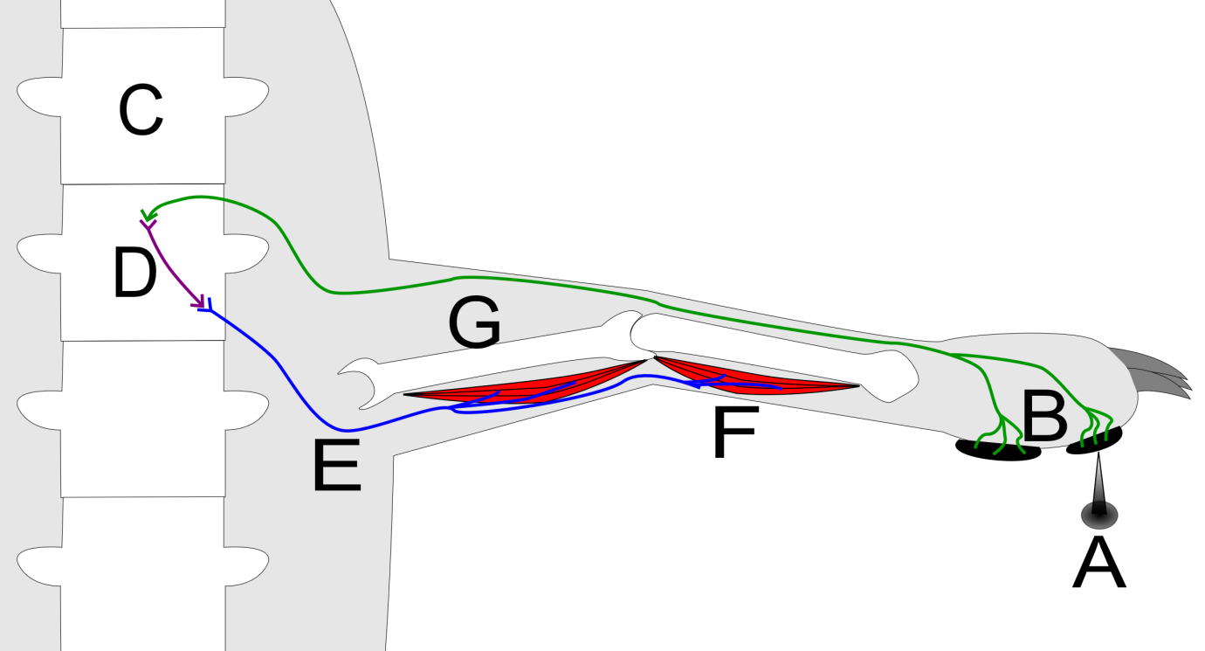

- The structure labelled ‘D’ could be described as

  - an afferent neuron carrying information away from the spinal cord.
  - an efferent neuron carrying information toward the spinal cord.
  - an interneuron transferring information from the afferent neuron to the efferent neuron.
  - pain receptors in the skin transferring information to the afferent neuron.

- Which of the following is not an example of an application of gel electrophoresis?

  - paternity testing
  - testing genetic material at crime scenes
  - testing for disease genes
  - amplifying DNA

Questions 17 and 18 refer to the diagram below.

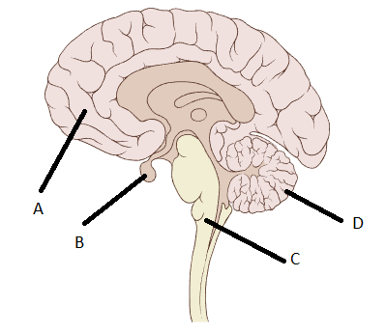

- Which part of the brain coordinates voluntary motor movement?

  - A
  - B
  - C
  - D

- Which part of the brain is a gland that produces many different hormones?

  - A
  - B
  - C
  - D

- Which of the following is associated with the overuse of prescription antibiotics?

  - causes hypoglycaemia
  - development of developmental disorders
  - acts as a diuretic
  - antibiotic resistant bacteria

- On hot days human beings start to sweat to try and cool the body down. What causes the sweating response?

  - thermoreceptors in the hypothalamus detect the increase in temperature and sends nerve impulses to the sweat glands to start sweating
  - thermoreceptors in the skin detect the increase in temperature and sends nerve impulses to the sweat glands to start sweating
  - thermoreceptors in the hypothalamus detect the increase in temperature and secretes hormones to the blood stream that cause the sweat glands to start sweating
  - thermoreceptors in the skin detect the increase in temperature and secrete hormones to the blood stream that cause the sweat glands to start sweating

Question 21 refers to the image shown below.

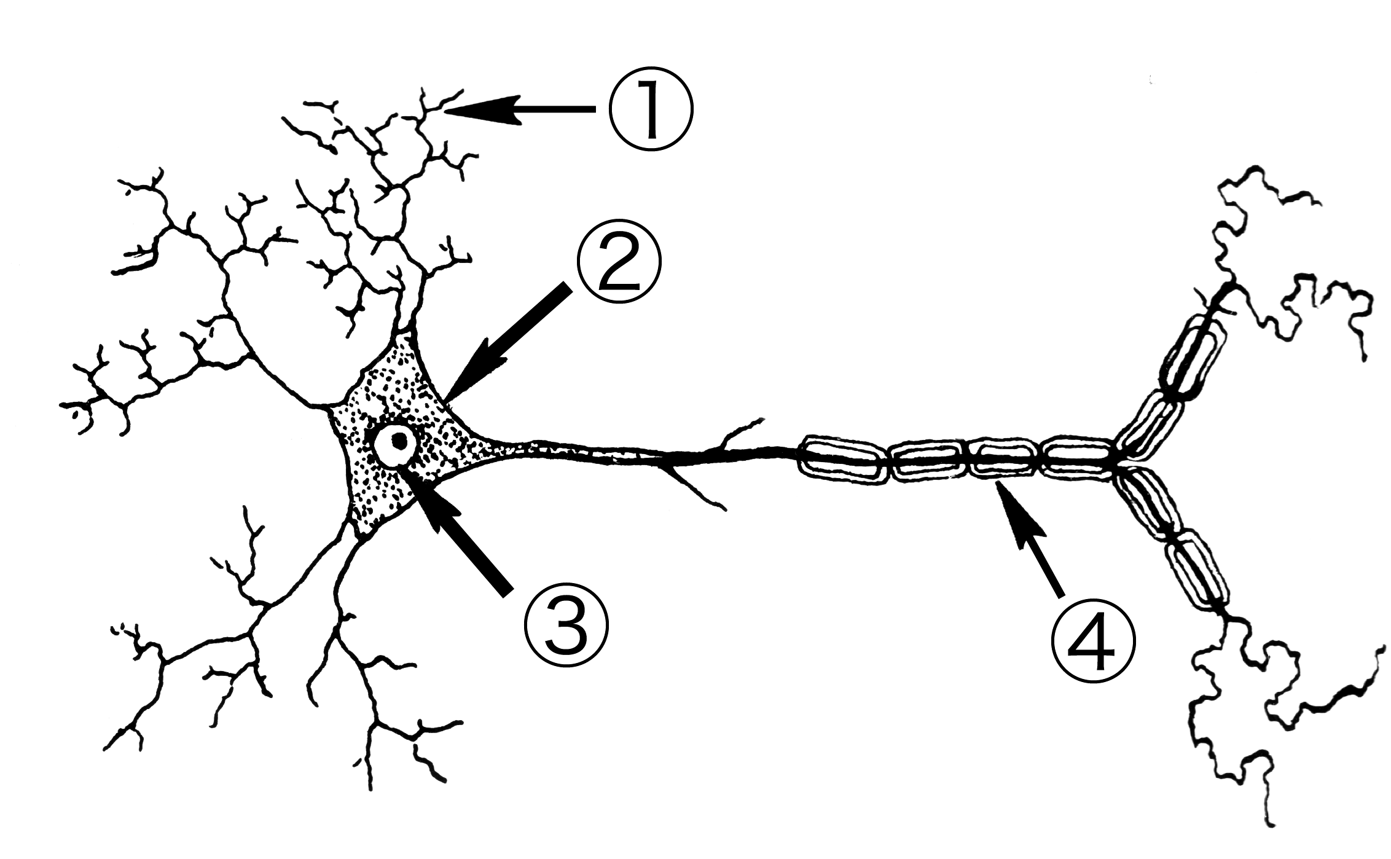

- Which is the correct pairing of the labelled parts of the neuron?

  - 1; axon terminals, 2; cell body, 3; nucleus, 4; Schwann cell
  - 1; dendrites, 2; axon, 3; nucleus, 4; myelinated sheath
  - 1; axon terminals, 2; axon hillock, 3; nucleus, 4; Schwann cell
  - 1; dendrites, 2; cell body, 3; nucleus, 4; myelinated sheath

- Which of the following pairings of receptors and stimuli is incorrect?

  - chemoreceptors detect chemicals
  - thermoreceptors detect temperature
  - pain receptors detect sugar concentration
  - osmoreceptors detect water concentration

- Which is the best definition for an antigen?

  - any substance capable of causing a specific immune response
  - any organism that causes disease
  - a substance produced in B-lymphocytes that stops bacterial proliferation
  - a substance that is used in all vaccines

- Which of the following shows the correct definition for the two main types of antibiotics?

  - Bactericidal antibiotics kill bacteria; Bacteriostatic stop bacterial reproduction
  - Bactericidal antibiotics kill bacteria; Bacteriostatic stop bacteria entering the cell membrane
  - Bactericidal antibiotics kill bacterial infected cells; Bacteriostatic stop bacterial reproduction
  - Bactericidal antibiotics kill bacterial infected cells; Bacteriostatic stop bacteria entering the cell membrane

Question 25 refers to the diagram below.
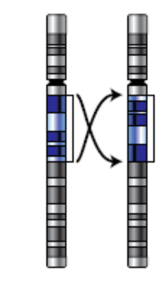

- The type of mutation depicted above is known as

  - a deletion.
  - an inversion.
  - a duplication.
  - a translocation.

- If a species becomes separated into two separate non-breeding populations, the separate gene pools might change over time to a point where the two populations can no longer interbreed. This is an example of

  - founder effect.
  - speciation.
  - random genetic drift.
  - a bottleneck event.

Question 27 refers to the diagram below of the forelimb of different organisms.

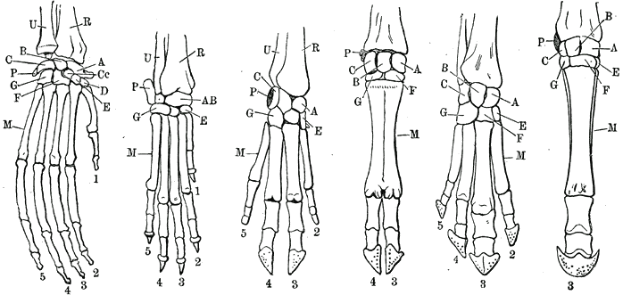

- Which principle of comparative anatomy does the image show?

  - vestigial organs
  - homologous structures
  - analogous structures
  - embryology

Question 28 and 29 refer to the following information:

A Human Biology student did an investigation to measure the change in mass of two deshelled eggs, one in a salt solution and one in distilled water. After completing the experiment, she decided to repeat it with two new pairs of eggs.

- Repeating the experiment helps to improve its

  - reliability.
  - validity.
  - measurement error.
  - accuracy.

- Below are the results of the experiment.

 | Change of mass in salt water (g) | Change of mass in distilled water (g)
Egg 1 | -24 | +52
Egg 2 | -31 | +71
Egg 3 | -35 | +60
Mean | X | Y

Which of the following show the mean scores for each condition?

- X= -29; Y=+60
- X= 7; Y=19
- X= -30; Y=+61
- X= -31; Y= +60

Question 30 refers to the image below.

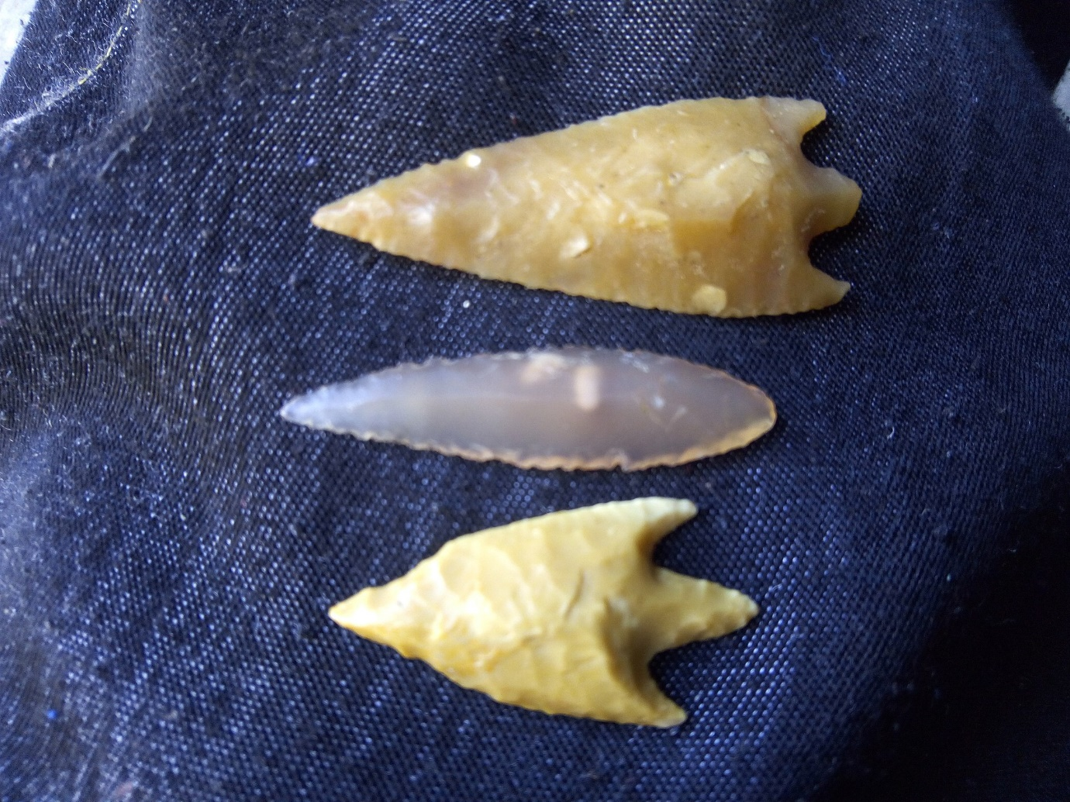

- Which Homo species would be most likely to have manufactured the tools above?

  - Homo neanderthalensis
  - Homo sapiens
  - Homo erectus
  - Homo habilis

Section Two: Short answer 50% (100 Marks)

This section has eight questions. Answer all questions. Write your answers in the spaces provided.

Supplementary pages for planning/continuing your answers to questions are provided at the end of this Question/Answer booklet. If you use these pages to continue an answer, indicate at the original answer where the answer is continued, i.e. give the page number.

Suggested working time: 90 minutes.

Question 31 (12 marks)

A year 12 Human Biology student was interested to find out whether or not reaction times were affected by the use of the dominant or non-dominant hand. To test this the student found a reaction time test on the internet where you had to click the mouse when a coloured dot changed. She did the test five times with each hand.

The results are found below.

Test number | Dominant hand (sec) | Non-Dominant (sec)
1 | 0.483 | 0.470
2 | 0.212 | 0.612
3 | 0.357 | 0.417
4 | 0.290 | 0.320
5 | 0.455 | 0.280

- Calculate the median score for each condition. (2 marks)

Dominant hand:
Description | Mark
0.357 seconds | 1
Total | 1

Non-dominant hand:
Description | Mark
0.417 seconds | 1
Total | 1

- Propose an appropriate hypothesis for this investigation. (1 mark)

Description | Mark
Statement linking independent variable to dependant variable | 1
Total | 1
Sample hypothesis:
Reaction time is faster with the dominant hand compared to non-dominant hand.

- Name two variables that the student should have controlled to make the investigation fair. (2 marks)

Description | Mark
Any two reasonable including; (accept additional answers that are correct)
Students use the same test on the internet | 1-2
there are the same conditions for the test
Students didn’t get to practice the test first
Total | 2

The student decided to conduct the same test on 10 of her class mates. Each participant had to complete the same test 5 times with each hand and then record the average.
The results are shown below.

Participant number | Average dominant hand (sec) | Average non-dominant hand (sec)
1 | 0.361 | 0.384
2 | 0.411 | 0.521
3 | 0.172 | 0.169
4 | 0.223 | 0.256
5 | 0.311 | 0.320
6 | 1.100 | 1.421
7 | 0.228 | 0.308
8 | 0.201 | 0.212
9 | 0.199 | 0.212
10 | 0.318 | 0.310
Average

- Use these results to create a graph showing the combined average time for the dominant hand and combined average time for the non-dominant hand. Graph this on the grid paper below. A spare grid is provided at the end of this Question/Answer booklet. If you need to use it, cross out this attempt. (5 marks)
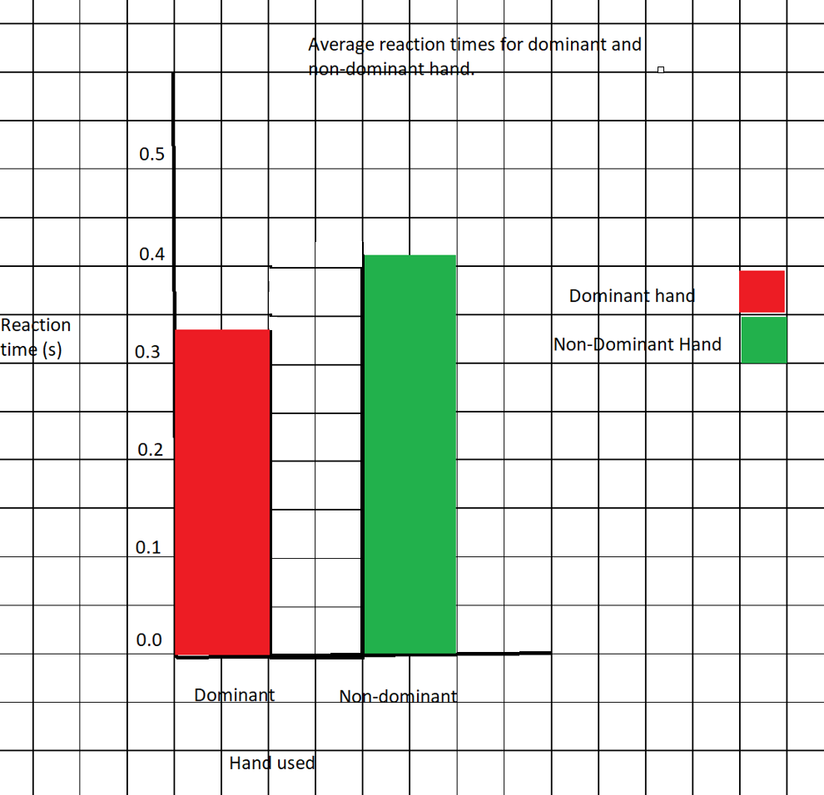

Description | Mark
Correctly constructs axes using appropriate scales. | 1
Correct plots using a column graph | 1
Labelling of axes with correct name and unit | 1
Identifies conditions using keys/labels | 1
Title appropriate with both independent and dependent variables included (dominant vs non-dominant; reaction time) | 1
Total | 5

- Which one of the participants could have been considered an outlier? Explain why.
(2 marks)

Description | Mark
Participant 6 | 1
Because the results were much slower than the other participants | 1
Total | 2
Question 32 (13 marks)

The diagram below shows an action potential.
`
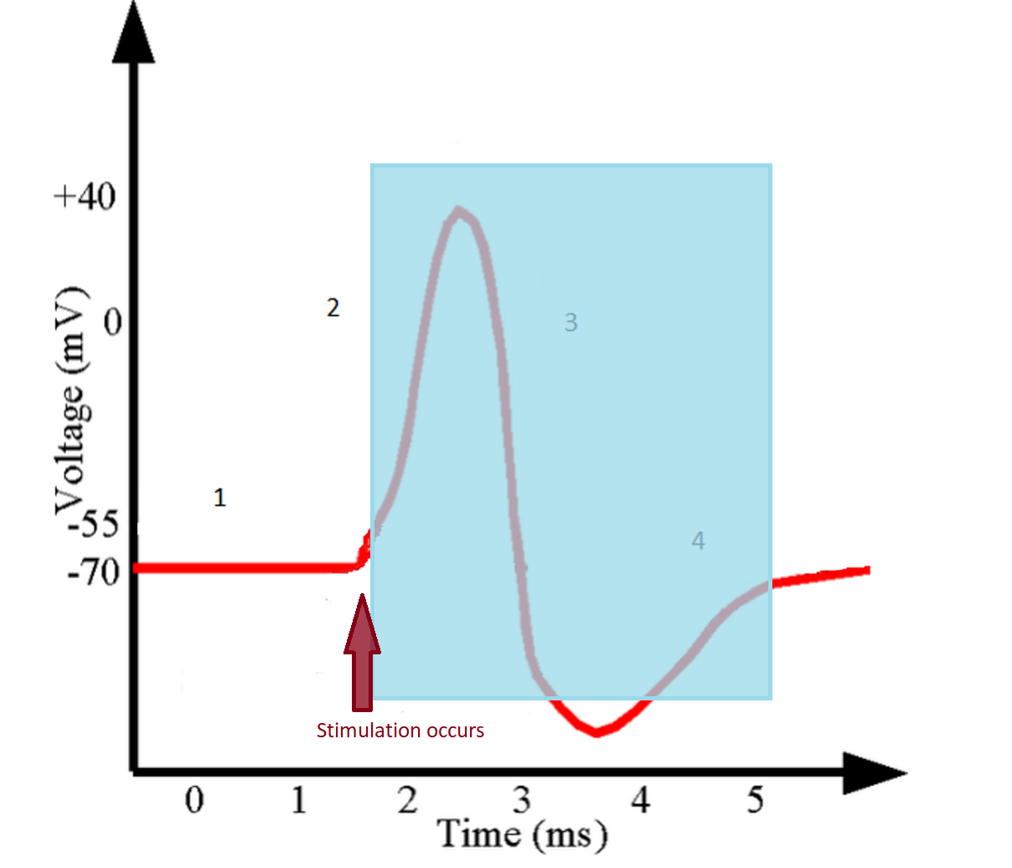

- Add a label to the graph above showing when stimulation occurred. (1 mark)

See label above

- Shade the area in the graph known as the refractory period. (1 mark)

See blue shading above

- Describe what is happening in the neuron during labels 2 and 3. (2 marks)

Description | Mark
Label 2: Na⁺ is entering the neuron/ cell membrane depolarises | 1
Label 3: Then K⁺ leaves the neuron/ cell membrane repolarises | 1
Total | 2
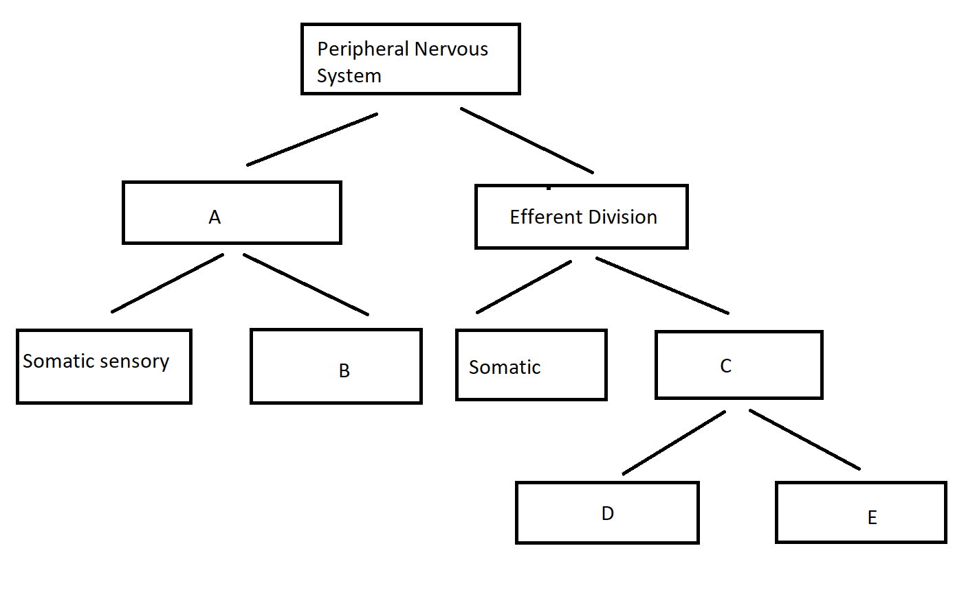
- Give the name for each division represented by the letters in the image above. (5 marks)
Description | Mark
A= Afferent Division | 1
B= Visceral Sensory | 1
C= Autonomic | 1
D= Sympathetic | 1
E= Parasympathetic | 1
(Note: D and E are interchangeable) Total | 5

- Describe any two (2) effects on the body when D and E are activated.
(4 marks)

Description | Mark
Sympathetic: Any two accurate (accept additional correct answers)
release of adrenaline/noradrenaline | 1-2
pupil dilation
increase heart rate
increased blood pressure
increased sweating
increased rate of breathing
increased depth of breathing
Parasympathetic: Any two accurate (accept additional correct answers)
decreased blood pressure | 1-2
decreased heart rate
decreased rate of breathing
decreased depth of breathing
pupil contraction
(Note: D and E are interchangeable) Total | 4
Question 33 (11 marks)

- Inflammation is the body’s response to an invading pathogen. In the table below outline the role of each substance listed in the inflammatory response.
(3 marks)

Description | Mark
Histamine: Increases permeability of capillaries to white blood cells/phagocytes. | 1
Heparin: Prevents blood clotting | 1
Phagocytes: Engulf and absorb pathogens and cell debris | 1
Total | 3

The diagram below represents a particular action of antibodies on E. coli.

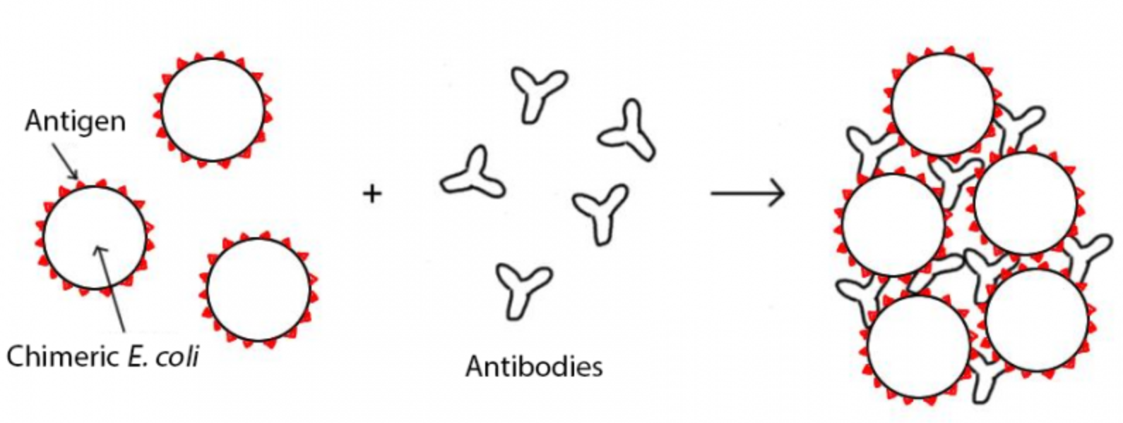

- Name this action of antibodies. (1 mark)

Description | Mark
Agglutination | 1
Total | 1

- Describe three other ways antibodies can act on pathogens.
(3 marks)
Description | Mark
Any three of the following for 1 mark each
Combine with foreign enzymes or toxins inactivating them | 1-3
Bind to the surface of viruses preventing them from entering cells
Coat bacteria to make them more easily consumed by phagocytes
Dissolve organisms
React with soluble substances making them insoluble so
phagocytes can consume them
Total | 3

Whooping cough is a disease that has had a huge increase in cases in the past decade. School aged children are being encouraged to be vaccinated against this pathogen. A student received the vaccine and then three months later was exposed to the whooping cough pathogen.

- On the axes below, draw and clearly label the antibody response for a student when they received the vaccine and when they were subsequently exposed to the pathogen. (4 marks)

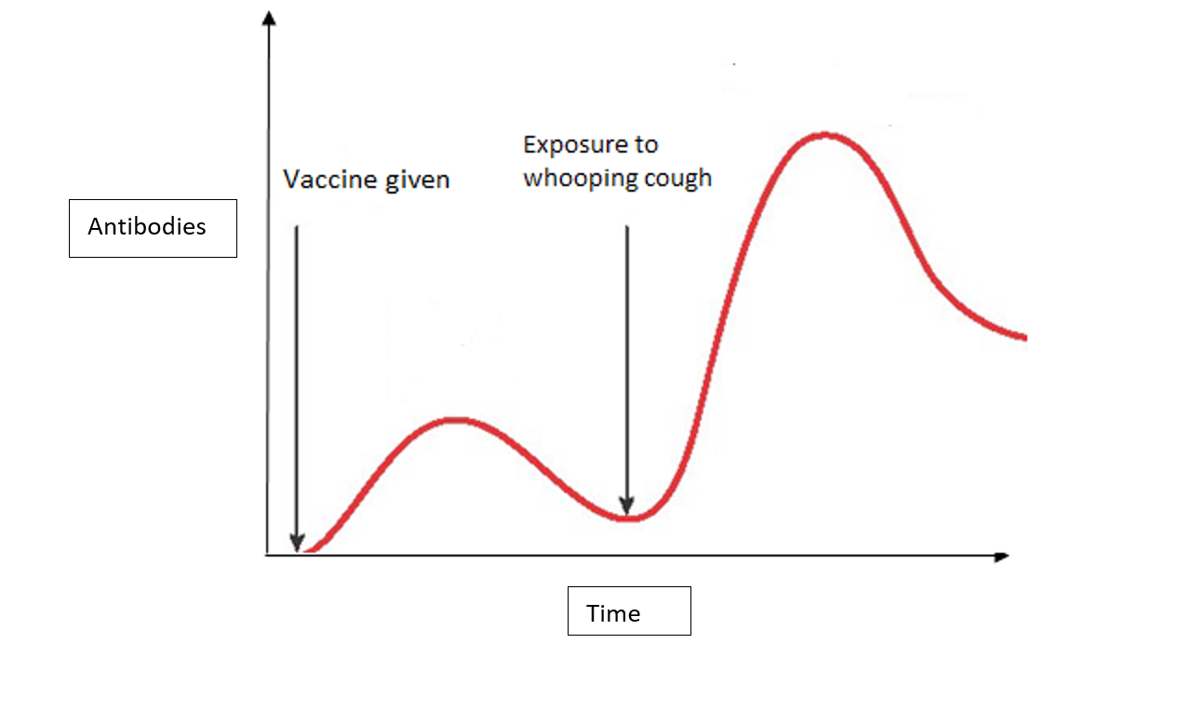
Description | Mark
Accurate curve for primary response | 1
Accurate curve for secondary response | 1
Accurate label for vaccine being received | 1
Accurate label for exposure to whooping cough | 1
Total | 4

Question 34 (11 marks)

The diagram below shows the development of different vertebrate species.
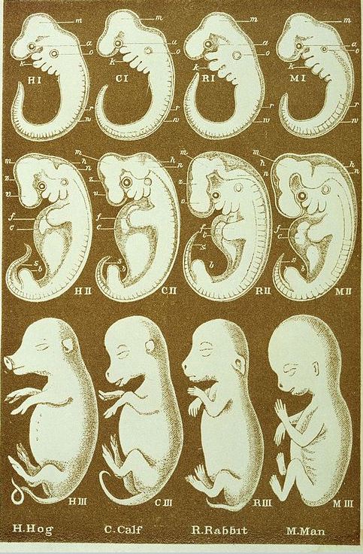

- What is the name of this comparative study of evolution called? Describe how it provides evidence for evolution. (3 marks)
Description | Mark
(Comparative) Embryology | 1
Closely related organisms show embryological development in the same sequence | 1
Organisms have features in the embryo (such as tails) that are not found in the adult form | 1
Total | 3

- Vestigial organs also provide evidence for evolution. Name one vestigial organ in humans and explain how it provides evidence for evolution. (2 marks)

Description | Mark
Any one the following:
Appendix | 1
Nictating membrane
Segmented abdomen
Body hair
Ear muscles
Wisdom teeth
Tail bone
The vestigial organ had a function in an ancestor species but has no/limited function in modern humans | 1
Total | 2

A new primate species was found deep in the jungle that had similar morphology to many of the great apes that still exist today, as well as some extinct species. Scientists studying this primate were debating whether to use comparative studies of biochemistry or comparative genomics. The scientists wanted to be as accurate as possible when determining the relatedness of the new species to known species.

- Which method would you recommend the scientist use and why?
(2 marks)

Description | Mark
Comparative genomics | 1
(Multiple triplets code for the same amino acid) different genetic sequences could produce the same protein sequences | 1
Total | 2

The new primate species was found in the same area in Borneo as the Bornean Orang Utan, and was determined to have a common ancestor with this species.

- Describe the likely process the newly discovered primate and the Bornean Orang Utan underwent to become two distinct species. (4 marks)

Description | Mark
There would have been variation in the ancestor species | 1
The ancestor species would have become isolated into two non-breeding groups | 1
There would have been different selection pressures in these two separated groups | 1
Over time the gene pool would have shifted until there were two separate species/ speciation occurs | 1
Total | 4

Question 35 (14 marks)

Human mitochondrial DNA (mtDNA) contains 37 genes, all of which are involved in protein synthesis and cellular respiration. Comparison of mitochondrial DNA has allowed scientists to track differences in mtDNA sequences between human groups to show migration patterns around the world of our original ancestors. These differences in sequences are due to mutations.

- What is a mutation? (1 mark)

Description | Mark
A permanent change in the DNA sequence | 1
Total | 1

- Name two environmental factors that can give rise to mutation. (2 marks)

Description | Mark
Any two of the following
UV radiation | 1-2
X-Rays
Ionising radiation
Certain chemicals
Total | 2

- How is mitochondrial DNA inherited? Why does this feature make it suitable for tracking human movement over time? (3 marks)

Description | Mark
Mitochondrial DNA is found in the cytoplasm on the egg/ovum and will be identical to your mothers mtDNA/ maternally inherited | 1
All mutations will be passed on to all offspring | 1
The gradual mutations will appear in different geographical areas at different times | 1
Total | 3
Nuclear DNA is also prone to mutation. These mutations can be somatic or germline.
- Describe two possible consequences of acquiring a somatic mutation. (4 marks)

Description | Mark
Nothing/ no effect | 1
the body’s immune system will destroy cells that contain (somatic) mutations/changes in DNA have no effect on protein synthesis | 1
Cancer- | 1
The mutations will interrupt the cell cycle and the cell will replicate uncontrollably | 1
Total | 4

- Describe the relationship between mutations and the change in gene pools over time due to natural selection.
(4 marks)
Description | Mark
Mutations increase the variation in a population | 1
Mutations will be negative, neutral or positive | 1
Positive mutations will increase in the population | 1
Natural selection occurs as gene pools shift to increase the favourable mutation | 1
Total | 4

Question 36 (11 marks)

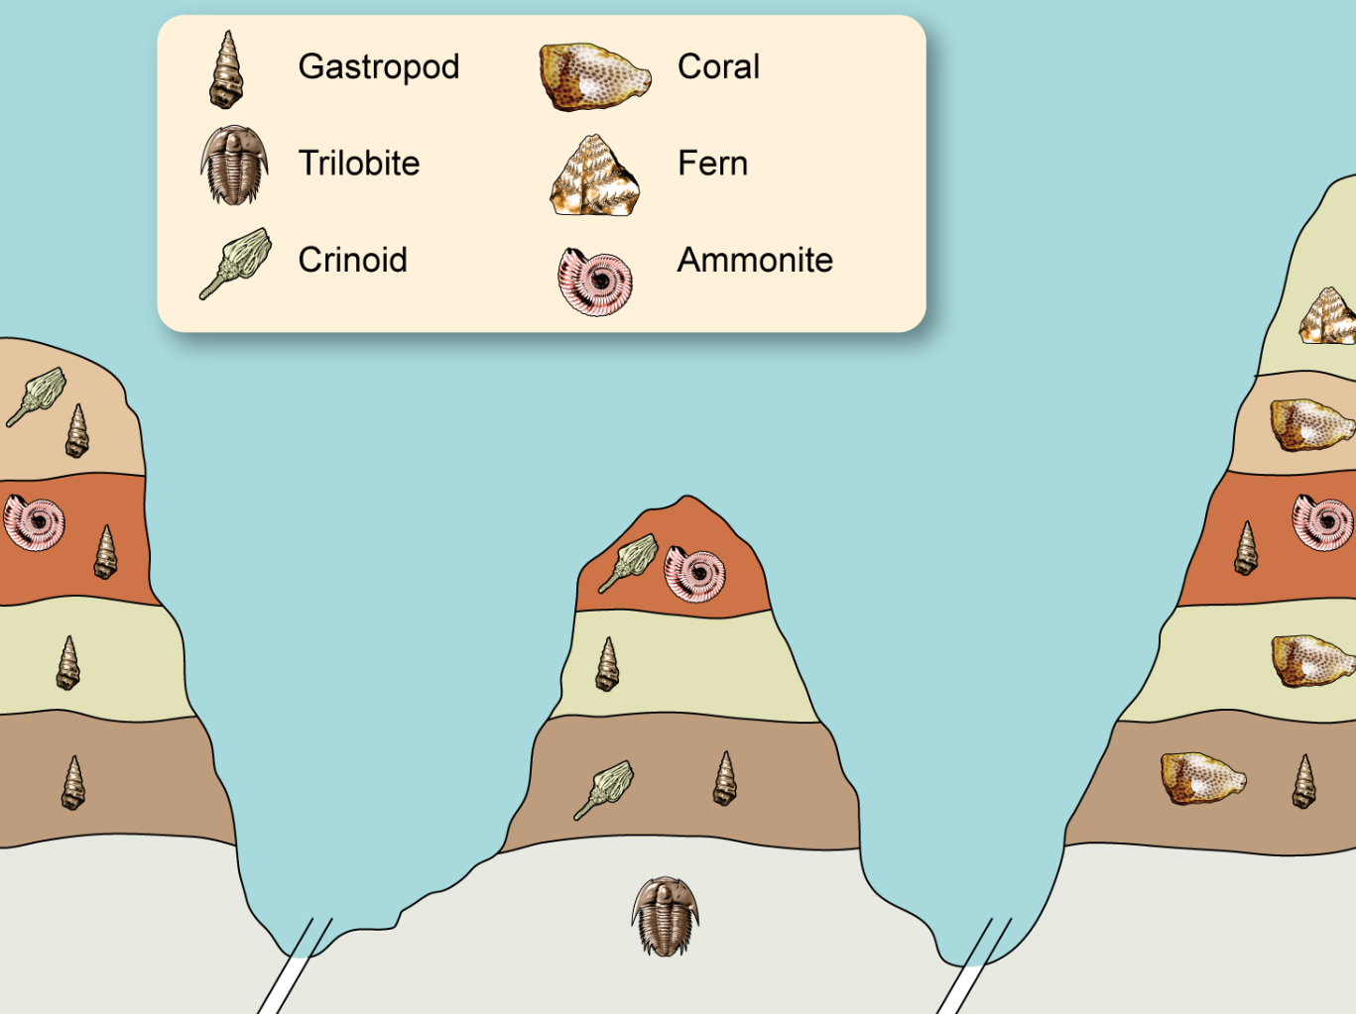

- Which is the most recently evolved fossil out of the ammonite and crinoid? Provide a reason for your choice. (2 marks)

Description | Mark
Ammonite | 1
The ammonite appears in a more recent layer/ higher layer than the crinoid | 1
Total | 2

- Explain whether the gastropod would be a suitable organism to be used as an index fossil. (2 marks)

Description | Mark
No | 1
The gastropod appears in multiple strata/does not appear in a small temporal distribution | 1
Total | 2

- What is absolute dating? Name two different types of absolute dating and for each identify the object that is tested and the age range for the object. (7 marks)

Description | Mark
Absolute dating: when an actual age in years is given to a specimen | 1
Any two of the following methods for 3 marks each
Method one
Potassium-Argon Dating | 1
Inorganic objects/ rocks are used | 1
Age range is rocks older than 100000-200000 years | 1
Method two
Carbon 14 Dating | 1
Organic material used/bones | 1
Less than 60000 years | 1
Method three (Note: Not required in the syllabus but correct)
Dendrochronology | 1
Tree rings/ trees | 1
Up to 9000 years | 1
Total | 7

Question 37 (18 marks)

The diagram below shows the glands of the endocrine system.

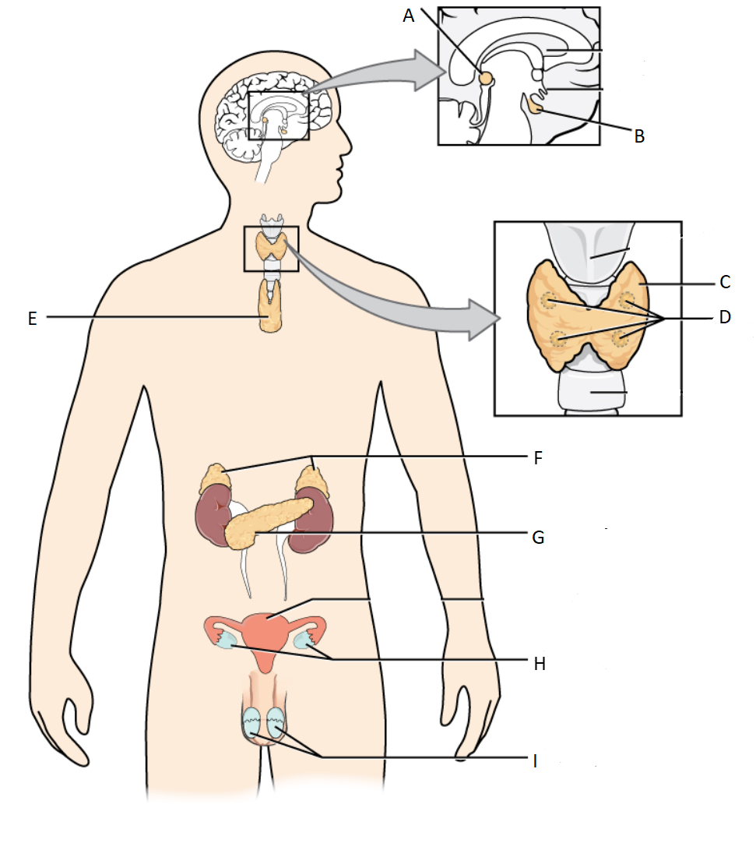
- Name the endocrine organ and give an example of one hormone it produces. (6 marks)

Description | Mark
C= Thyroid Gland | 1
C= Thyroxine | 1
D= Parathyroid | 1
D= Parathyroid hormone/ parathormone/ PTH | 1
G= Pancreas | 1
G= Insulin/glucagon | 1
Total | 6

- Cortisol and glucagon are both hormones that work to increase the levels of glucose in the blood. However, they differ in their mode of action. Cortisol is a lipid soluble hormone and glucagon is a water-soluble hormone. In the table below contrast the mode of action of these two hormones. (6 marks)

Description | Mark
Cortisol passes through the cell membrane | 1
Glucagon binds to receptors on the membrane | 1
Cortisol binds directly to the DNA | 1
Glucagon has a secondary messenger | 1
The effects of cortisol will last longer | 1
The effect of glucagon will last for a much smaller amount of time | 1
Total | 6
A labelled diagram that illustrates any of the above points can be used in students’ answers

- Hypothyroidism is a disorder of the endocrine system. State two possible causes, two likely symptoms and two methods that could be used to treat the symptoms of this disorder. (6 marks)

Description | Mark
Any two causes from the following:
Deficiency in thyroxine | 1-2
Hashimoto’s disease
Deficiency in TSH
A low iodine diet
Any two symptoms from the following:
Tiredness/lethargy | 1-2
Goitre
Weight gain
Slow heart rate
Intolerant to cold
Any two treatments from the following:
Iodine enriched diet | 1-2
Synthetic Thyroxine hormones
Synthetic TSH hormones
Total | 6

Question 38 (10 marks)

In March 2019 in Hubei Province, China, thousands of fossils washed up on a beach. These fossils were a particularly unusual find because they were soft-bodied organisms including many species of jellyfish, sea anemones and algae and much of their soft tissue was preserved.

- In the table below compare and contrast the conditions required for the fossilisation of soft-tissue compared with hard tissue, such as teeth and bone. (3 marks)

Description | Mark
Compare: Both tissues Low oxygen/rapid burial | 1
Contrast: Soft issue; acidic deposit | 1
Contrast: Hard tissue; alkaline deposit | 1
Total | 3

- What four conditions are usually required for a fossil to form? (4 marks)

Description | Mark
Rapid burial | 1
Presence of hard parts of the organism | 1
Absence of decay causing microorganisms | 1
A long period of stability | 1
Total | 4

- The fossil record is incomplete and does not account for all of the organisms that have existed. Describe three reasons for the incomplete nature of the fossil record. (3 marks)

Description | Mark
Any three of the following
Fossilisation is rare/not all organisms have become fossils | 1-3
Very few of the fossils that exist have been discovered/Fossils have been destroyed (by industry or agriculture)
Accurate dating of fossils cannot always occur/carbon dating limited to organisms less than 60000 years old
Very few fossils of whole organisms exist/mostly fragments found
Total | Any 3

Section Three: Extended answer 20% (40 Marks)

This section contains three questions. You must answer two (2) questions. Write your answers on the pages following Question 41.

Supplementary pages for planning/continuing your answers to a question are provided at the end of this Question/Answer booklet. If you use these pages to continue an answer, indicate at the original answer where the answer is continued, i.e. give the page number.

Suggested working time: 50 minutes.

Answer any two questions from Questions 39 to 41.

Indicate the questions you will answer by ticking the box next to the question. Write your answers on pages that follow.

Question 39 (20 marks)

- An evolutionary trend is a pattern of directional change that occurs in several species over a long period of time. Referring specifically to prognathism, size of brain case compared to body size, and dentition, describe the changes seen in the following Hominid species.
- Paranthropus robustus
- Homo habilis
- Homo erectus
(9 marks)

Description | Mark
Prognathism:
Paranthropus robustus is the most prognathic | 1
Homo habilis is more prognathic than erectus and less than robustus | 1
Homo erectus is the least prognathic | 1
Size of brain case:
Paranthropus robustus has the smallest brain case | 1
Homo habilis has a larger brain case than robustus and less than erectus/ 800cc | 1
Homo erectus has the largest brain case/ 1000cc | 1
Dentition:
Paranthropus robustus U shaped jaw/ large molars | 1
Homo habilis is more parabolic than robustus, less than erectus | 1
Homo erectus is more parabolic/large canines | 1
Total | 9

In 2015, palaeontologists uncovered fossilised remains of a new Hominid species Homo naledi in a complex cave network in South Africa. This species was identified to have legs and feet similar to Homo sapiens while having hands and a pelvis similar to Australopithicus afarensis. The Homo naledi specimens were dated as being between 36000 and 45000 years old.

- Describe the features you would expect to see in the legs, feet, hands and pelvis of Homo naledi.
(8 marks)

Description | Mark
Legs:
Broad epiphysis (buttressed lateral condyle) | 1
Comparatively long femur | 1
Feet: Any two
Transverse arch | 1-2
Longitudinal arch
Large calcaneus
Large big toe
Parallel big toe
Hands: Any two
Shorter thumb and long curved fingers | 1-2
Less opposability
Power grip but no/limited/some precision grip
Pelvis:
Long | 1
Narrow | 1
Total | 8

- Name the dating method that was used to assign an age to the Homo naledi specimens and explain why this method was used. (3 marks)

Description | Mark
Carbon 14 dating | 1
Carbon 14 is up to 60000 years old which is the age range of the specimen | 1
Carbon 14 is used on organic specimens/need more than 3 grams | 1
Total | 3

Question 40 (20 marks)

Susan and her mother Lesley are working in a basement fixing a leaking gas heater. The space is very small and poorly ventilated and, after a while, both of them notice an increase in the rate and depth of their breathing. As they noticed the increased respiratory rate, they have rushed up the stairs and opened windows until their breathing rates returned to normal.

- Describe the homeostatic mechanism that caused the increased breathing rate in this situation. In your answer describe how the body detects and maintains gas concentrations in the blood. (12 marks)
Description | Mark
Stimulus:  High blood CO₂ concentrations or ↑H⁺ or ↓pH | 1
Receptor:  Chemoreceptors | 1
In the carotid and aortic bodies, medulla oblongata | 1
Modulator:  Medulla oblongata | 1
Effector:  Diaphragm | 1
Intercostal muscles | 1
Sympathetic NS | 1
Response:  Increase rate and strength of diaphragm contraction. | 1
Intercostal muscles contract to allow deep breathing | 1
Increase sympathetic nerve impulses | 1
Feedback:  Negative feedback achieved | 1
Breathing rate and depth returned to normal/ original stimulus reversed | 1
Total | 12

The message to increase the rate and depth of breathing is controlled by nervous impulses.

- Describe how an unmyelinated nerve cell transmits an impulse.

(8 marks)
Description | Mark
Any eight of the following
Impulse passed at each point of the membrane/impulse does not jump between nodes of Ranvier | 1-8
Resting membrane potential is -70mV
Stimulus is received and voltage gated sodium channels open allowing Na⁺ to enter neuron
If threshold of – 55 mV is reached -
then Na⁺ flood into the neuron causing a rapid depolarisation (action potential)
Sodium gates close and potassium gates open
K⁺ flood out of the neuron causing repolarisation
Hyperpolarisation occurs and potassium gates close
The Na⁺/K⁺ pump, pumps three Na⁺ out and two K⁺ into the neuron
This restores the original ion concentration and the resting membrane potential to -70mV
Total | 8

Question 41 (20 marks)

Recombinant organisms are created to manufacture a variety of products for humans to use.

- Describe the steps involved in creating a recombinant organism for the manufacture of a human hormone or vaccine. (10 marks)

Description | Mark
Any 10 of the following
Use PCR to amplify the gene of interest from the pathogenic organism/human DNA | 1-10
Use restriction enzymes to cut out the gene of interest from the pathogenic organism/human DNA
producing ‘sticky ends’/staggered ends
Isolate a plasmid from a bacterium which will act as a vector
Use the same restriction enzymes to cut the plasmid producing ‘sticky ends’
Insert the gene of interest into the plasmid
Treat the plasmid with DNA ligase to combine the gene of interest to the plasmid in a process called ligation
Reinsert the plasmid into the bacterium
Allow the bacterium to manufacture the hormone/vaccine in a nutrient broth
Take samples of the broth
Purify the samples to isolate the hormone/vaccine
Package the hormone/vaccine in a form that humans could consume
Any 10 Total | 10

There are several different types of vaccines that have been manufactured for different uses. The decision to vaccinate or not can be influenced by various issues.

- Describe two different risk factors associated with vaccinations. (4 marks)
Description | Mark
Any two risk factors with correct description
Risk factor one
Allergic reaction | 1
Egg is often used as a medium and many people have an allergy to eggs/ yeast can be used which people can be allergic to | 1
Risk factor two
Cross species viral contamination | 1
Impossible to completely isolate one virus from others in the animal tissue culture | 1
Risk factor three
Contract the disease | 1
(In individuals with a weakened immune system) live-attenuated vaccines can mutate becoming virulent | 1
Total | 4

- How do vaccinations provide immunity against disease? (6 marks)

Description | Mark
Vaccines contain dead/attenuated/sub units/toxoids derived from the pathogen. | 1
This vaccine will be recognised by your B-lymphocytes | 1
B-Lymphocytes will become sensitised, enlarged and divide into many clones | 1
Most B-lymphocytes become plasma cells and secrete antibodies | 1
Some B-lymphocytes become memory cells | 1
Memory cells stay in the body and will flood the body with antibodies/react much faster if the person becomes infected with the pathogen which prevents illness. | 1
Total | 6

END OF QUESTIONS

ACKNOWLEDGEMENTS

Question 15 Reflex [image] retrieved 23 March, 2019 from https://commons.wikimedia.org/wiki/File:Reflex_Arc.svg

Question 17 Adapted from brain [image] retrieved 23 March ,2019 from https://commons.wikimedia.org/wiki/File:Brain_human_sagittal_section.svg

Question 21 Neuron [image] retrieved 17 March, 2019 from https://commons.wikimedia.org/wiki/File:Neuron_(PSF).png

Question 25 Adapted from Mutation [image] retrieved 24 March, 2019 from: https://commons.wikimedia.org/wiki/File:Chromosomenmutationen.png

Question 27 Comparative anatomy [image] retrieved 23 June, 2019 from https://en.wikipedia.org/wiki/Forelimb#/media/File:Handskelett_MK1888.png

Question 30 Stone tool [image] retrieved 23 June, 2019 from: https://upload.wikimedia.org/wikipedia/commons/3/3d/Tools_Stone_age.jpg

Question 32 Adapted from Action Potential [image] retrieved 16 May, 2019 from: https://commons.wikimedia.org/w/index.php?title=Special:ElectronPdf&page=File%3AActionPotential.png&action=show-download-screen

Question 33 Action of Antibodies [image] retrieved 24 March, 2019 from: http://2014.igem.org/Team:WPI-Worcester/Background

Question 34 Vertebrate development [image] retrieved 22 June, 2019 from: https://upload.wikimedia.org/wikipedia/commons/3/35/Haeckel%27s_Evolution_of_Man_Wellcome_L0032934.jpg

Question 36 Rock strata [image] retrieved 17 March, 2019 from: https://commons.wikimedia.org/wiki/File:Fossils.png

Question 37 Adapted from endocrine system [image] retrieved 11 March, 2019 from: https://sco.wikipedia.org/wiki/File:1801_The_Endocrine_System.jpg

